TRAINING AND PLACEMENT CELL
ACADEMIC YEAR 2024-2025
AASAANS FDP on 26.02.2025 and 27.02.2025
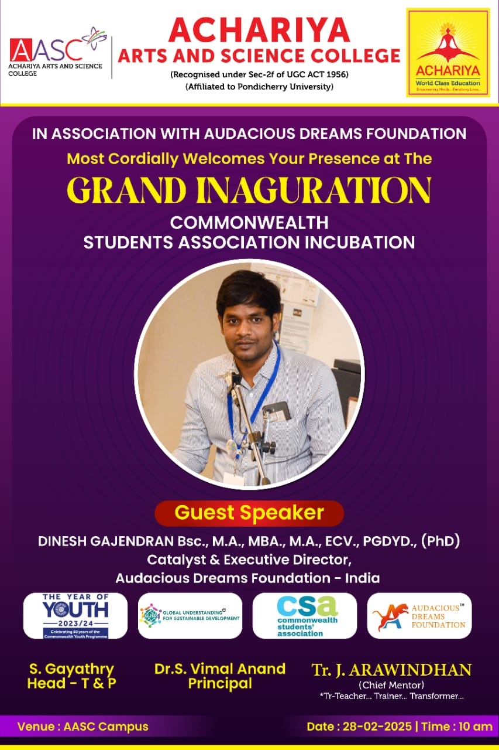
The Training and Placement Cell in association with Audacious Dreams Foundation inaugurated the Commonwealth Students Incubation Association at AASC Campus and organized an orientation programme on 28.02.2025. The session was led by Mr DINESH GAJENDRAN , Catalyst & Executive Director of Audacious Dreams Foundation, India. The session had a great positive impact on our students, inspiring them to pursue the path of entrepreneurship by understanding the importance of Start-ups.

